Neon Retro TV Rave Kandi Charm | 3D Printed Bead
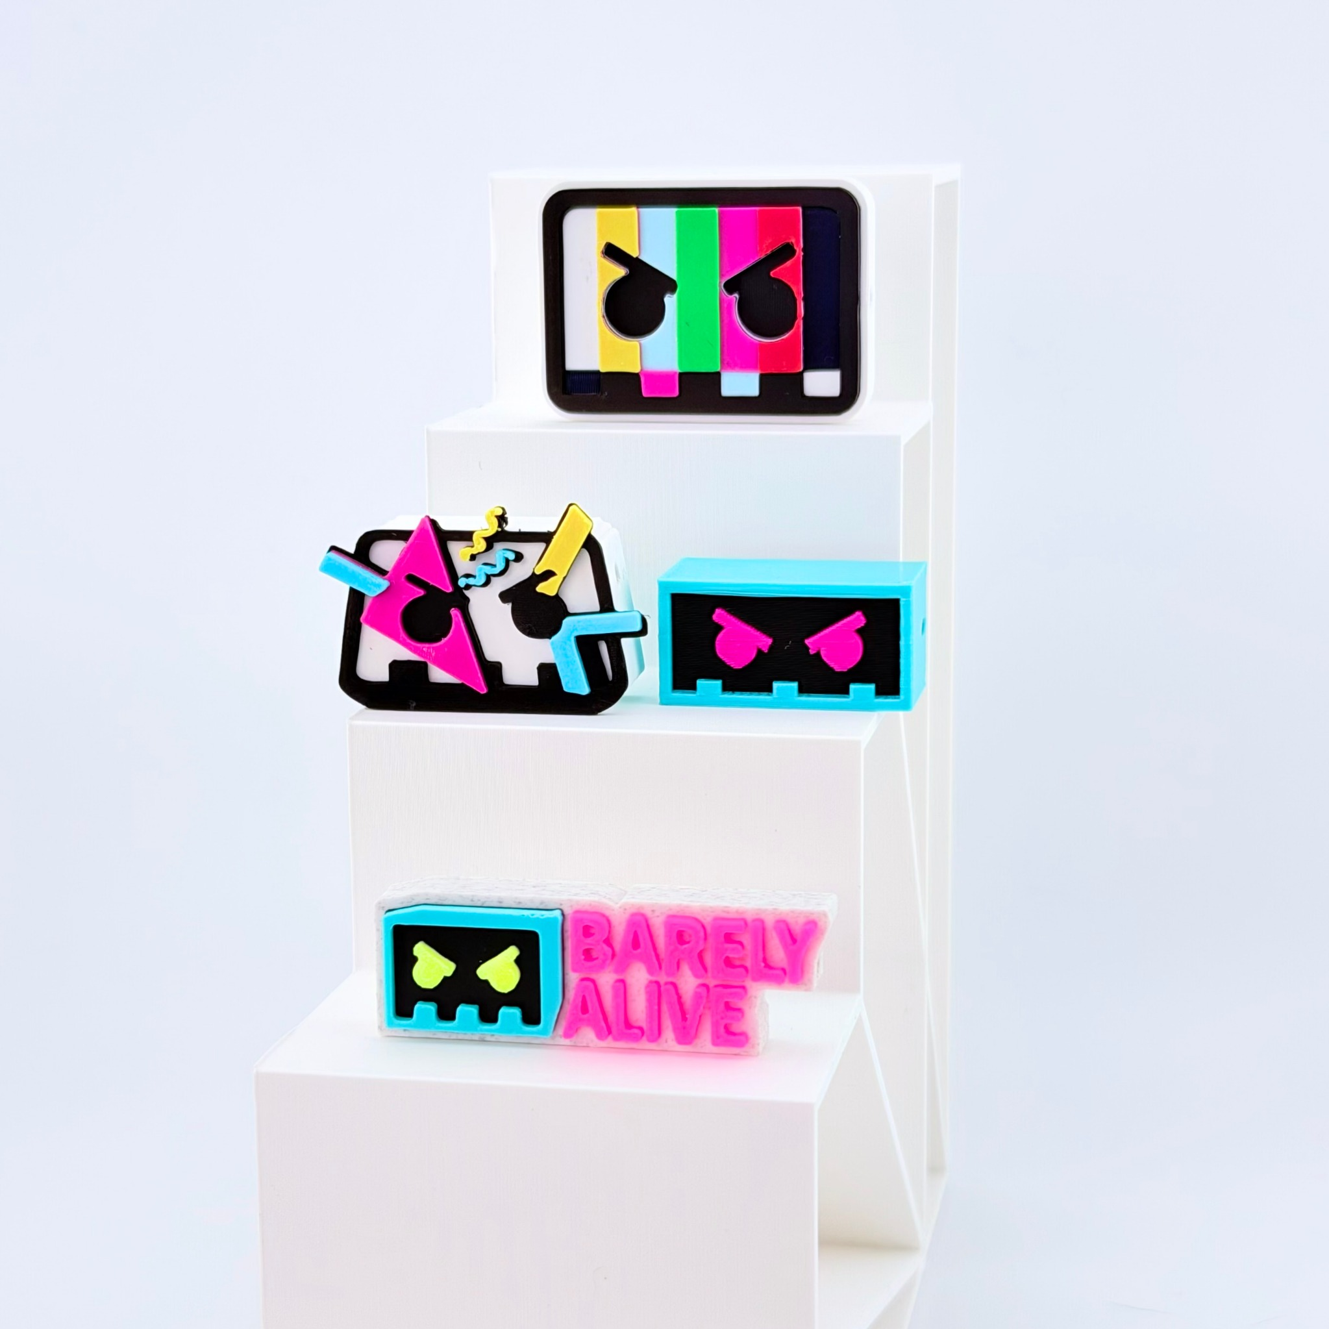
3D-printed PLA bead charm with a built-in threading hole, one design sold by color. Photo shows the Neon Retro set; this listing is the retro TV design (top). No clips or springs.

Keyword Strategy
Primary: rave kandi charm
Secondary: 3D printed kandi bead, kandi bracelet charm, festival jewelry supplies, retro TV charm, EDM kandi accessories
Keywords are relevance-based recommendations; search volumes were not independently verified.

Shopify
Product title: Neon Retro TV Rave Kandi Charm | 3D Printed Bead
Bring retro arcade energy to your next kandi creation with this colorful 3D-printed bead charm! Shaped like a vintage TV with neon color bars and a bold pixel-style face, this lightweight PLA charm adds a playful focal point to kandi bracelets, necklaces, and festival accessories. Each charm includes a built-in bead hole for threading onto kandi string or incorporating into custom jewelry projects. Pick your color in an 11, 22 or 33 pack and get ready to make, wear, and trade with your rave crew.
- Retro TV Design: Neon color bars with a bold pixel-style face.
- Lightweight PLA: 3D-printed plastic charm for kandi making.
- Built-In Bead Hole: Designed for bracelets, necklaces, and crafts.
- Resealable Packaging: Charms packaged together in a protective resealable bag.

SEO page title: Neon Retro TV Kandi Charm | Rave Bead Charm
Meta description: Shop a neon retro TV rave kandi charm. Lightweight 3D-printed bead for festival bracelets, necklaces, and custom kandi jewelry. Charms only, no bracelet.

Etsy
Product title: Neon Retro TV Rave Kandi Charm, 3D Printed Kandi Bead for Festival Bracelets, EDM Jewelry Making Supplies
Add a splash of neon nostalgia to your kandi creations! This colorful 3D-printed rave kandi charm is shaped like a retro TV with bright color bars and a playful pixel-style face. Made from lightweight PLA plastic, each charm features a built-in bead hole for creating kandi bracelets, necklaces, and personalized festival jewelry. Mix it with your favorite pony beads, build one-of-a-kind PLUR bracelets, or add it to your next kandi trading collection. Materials: PLA plastic. Choose your color and pack size; charms only, bracelet not included.
- Retro TV Design: Vibrant neon color bars and a pixel-style face.
- 3D-Printed PLA: Lightweight decorative bead charm.
- Built-In Bead Hole: For threading onto kandi bracelets, necklaces, and crafts.
- Resealable Bag: Charms packaged together for convenient storage.

13 Etsy tags: rave kandi charm, kandi beads, 3d printed beads, festival beads, edm kandi, bracelet charms, jewelry making, neon kandi charm, retro tv charm, plur trading beads, focal beads, pony bead charm, diy kandi
Recommended category: Craft Supplies & Tools > Beads > Plastic Beads (confirm available path)

TikTok Shop
Product title: Neon Retro TV Rave Kandi Charm, 3D Printed Bead for Bracelets & Festival Jewelry
Give your kandi a neon arcade upgrade! This colorful 3D-printed rave kandi charm is shaped like a retro TV with bright color bars and a bold pixel-style face. Made from lightweight PLA plastic, it includes a built-in bead hole for adding to bracelets, necklaces, and custom festival jewelry. Mix, create, and trade with your rave crew!
- Retro TV Design: Bright color bars and a pixel-inspired face.
- Lightweight PLA: 3D-printed decorative bead charm.
- Built-In Bead Hole: Designed for kandi bracelets and necklaces.
- Color & Pack Choices: Loose charms in your pick of color, in 11, 22 or 33 packs.
- Resealable Packaging: Charms packaged together in a protective bag.

Recommended category: Jewelry Making Supplies / Beads & Jewelry Findings (confirm in Seller Center)

